JC2066 IT Professionals and Society (Semester A,2022-23)

IT,

an antidote of medical resources unfairness

|  |  |  |  |
| --- | --- | --- | --- |
| Student ID | Name | Contribution | Description of contribution |
| 58520942 | Gong Yu Wen, Jacob | 50% |  |
| 57850299 | Lau Lap Hei, Issac | 50% |  |

Date:17-11-2023

**Table of Contents**

**Background** **3**

**Existing problems and solutions 4 -5**

**Design space 6**

**Challenge 7**

**Conclusion 8**

**Background**

Medical resource unfairness has long been an important but unsolved social problem. It is a worldwide problem which specifically happens in high-popularity districts and developing countries. [background]

It can be imagined that a patient suddenly gets a covid in a medical resource shortage area and goes to hospital. Since the hospital has not enough doctors, the patient must wait a long time, suffering from the pain. Finally, it is his/her turn to see the doctor. However, the doctor cannot be sure whether he/she has a hard cough or other diseases (Even if he/she has covid, the doctor still cannot give you the best treatment due to the medical resources shortage). The doctor may only observe your condition and give you some medicine which is not that suitable. There may be better resources but the patients in such areas are usually privileged. Therefore, it is hard for them to afford it. The result worsened and circulated in those areas. [application scenario]

This case illustrates a part of what this problem causes, which has further effect on our society and future lives. [influence on society and future lives]

As for society, medical resource unfairness may cause threat to social stability. When a sizable portion of the population is excluded from healthcare resources, dissatisfaction within society can increase, leading to heightened social tensions and posing a threat to social stability. Besides, the treatment delay and insufficient treatment may lead to health disparities widening, result in poorer average health conditions for low-income people and further strengthen the inequality.

As for individuals, medical treatment quality is deeply associated with our own welfare. From a physical perspective, if one cannot get adequate treatment, he or she will suffer a lot from pain, not to mention the further effect on his or her body. Furthermore, the worsening physical condition of an individual may result in lower productivity, leading to more financial issues. Also, for those who are still healthy, it’s horrible and uncomfortable to live in such an area.

In medical resource unfairness, main conflicts exist between three stakeholders which are patients, medical institutions, and the government. Patients hope to receive necessary medical services in a timely manner and avoid long waits and treatment delays. They need fair and equitable distribution of healthcare resources. Medical institutions aim to provide high-quality medical services, but they may face challenges such as a shortage of healthcare professionals and insufficient equipment. They require more healthcare personnel and equipment to meet patients' needs. The government and decision-makers need to formulate policies and measures to address the issue of inadequate healthcare resources. This may include increasing training for healthcare professionals, improving the supply of medical facilities and equipment, and enhancing the efficiency of healthcare service distribution. [special needs of different stakeholders]

Some of these special needs can be solved due to a series of IT technologies, which will be further discussed in the following sections.

**Existing problems and solutions**

1.Geometric unequal distribution of doctors

Doctors are unequally distributed among the degree of development among regions. Richer places usually get more doctors for the proportion of populations. According to Schoenstein and Buchan (2016), there are geographic imbalances in the distribution of doctors in OECD countries. Moreover, Carr-Hill and Carrie (2013) state that there are clear differences between richer and developing countries. It may be because doctors are trained more and get higher salaries in well-developed countries. This shows the unfairness of the proportion of doctor amount among the worlds.

Existing solutions: International organizations such as Médecins Sans Frontières encouraging doctors to cure patient in developing countries.

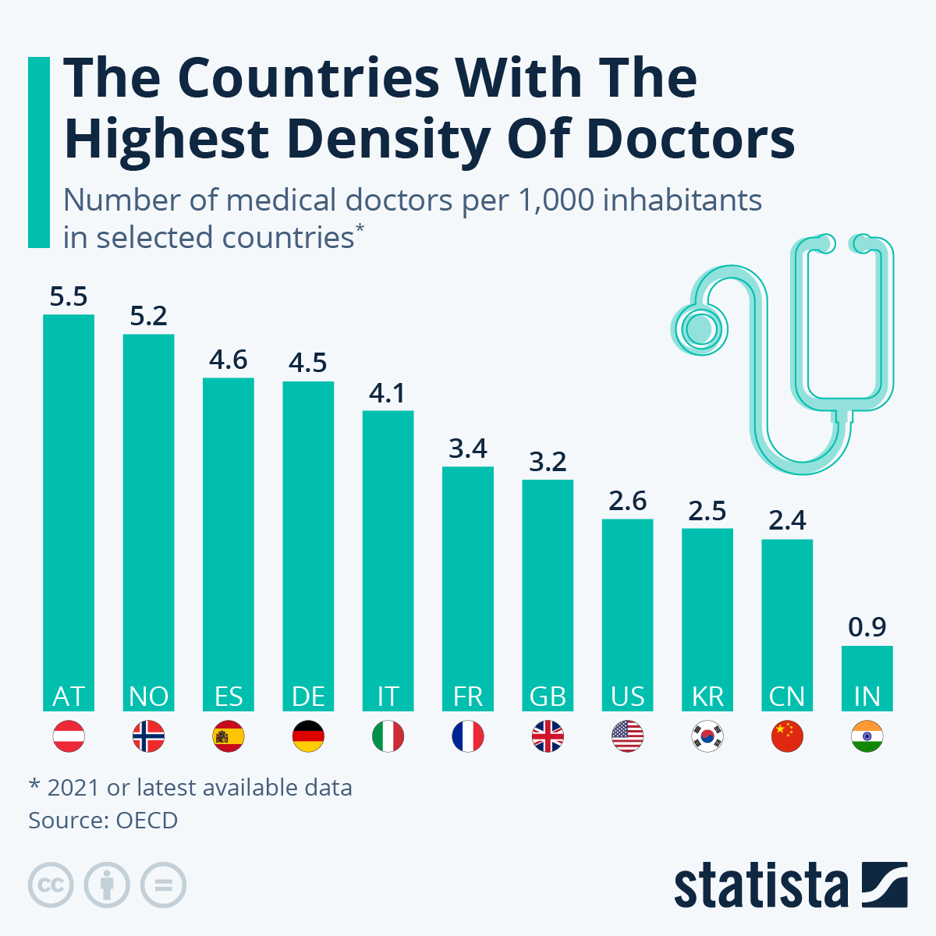

2.Shortage of doctor

The number of doctors is far from enough from a global perspective. According to WHO (2020), the average number of doctors is 16 per 10,000 all over the world. WHO also states there is 7 million health workers shortage in global, which may rise to 13 million by 2035. Growing populations and growing serious natural diseases are some of the factors aggravating the problem.

Existing solutions: Provide more supplies for doctors.

3.High expenses to the proportion of income.

Medical resources are relatively expensive all over the world.

According to world Bank, People in developing countries spend over $80 per person annually to access health services, and such expenses hit the poor the hardest. In some low-developed countries such as Sudan, it is already 10% more than the annual total income. In developing countries, it is hard affordable for grassroots.

Existing solutions: Subsiding from government to Vulnerable groups or support by organizations to developing countries.

4. Government's inadequate influence health resource allocation policies

It can be observed that in the same city, rich regions have more medical districts. Using HK public hospital as an example, there are near 30 hospitals distributed in Kowloon and HK Island and there are only about 15 in new territories, sharing by half of the population in HK, this shows the unequal distribution of medical resources. Private hospitals are also mainly distributed in Kowloon and New territories. It may be because such a hospital region is developed by policies of Government, but the new town’s equipment is still not balanced.

Existing solutions: Private doctors are hired to work in public hospitals to reduce stress. Some newspaper addressing Media pressure to force government see the problem.

5.Lack of drugs

This is one of the major causes of medical resources unfairness in low-income countries. According to UN, in September 2021, only 3 percent of people in low-income countries had been vaccinated by one dose, while in well-developed countries, it is 60.18%. Only one per cent of vaccine have been administered in low-income countries in the 10 billion doses given out worldwide. This shows the extreme unequal distribution of vaccines between low-income and well-developed countries.

Existing solutions: Donation of vaccines from well-developed countries and international organization to less-developed countries.

Accelerating supply of vaccines for developing countries by World Bank.

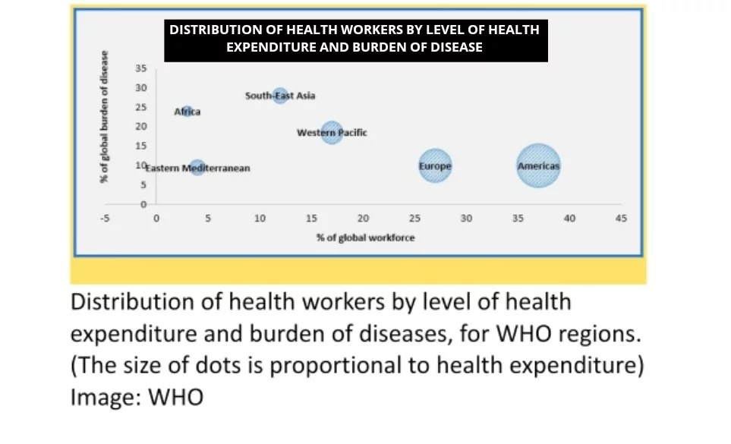

**Design space & IT techs**

1.**Geometric unequal distribution of doctors-Building a telemedicine system**

Some poor districts may have few doctors because there are few local doctors. Those regions are also relatively poor, the income of doctors is low, such that few overseas doctors are willing to come. The method can apply to the lack of doctor’s region, which can increase the number of doctors and reduce the waiting time of the patient.

**Tech**: By using **telehealth technologies**, doctors can see patients far away by platforms such as zoom. Doctors can give recommendations, ask the patients about their symptoms, and decide on the medicine

2.**Shortage of doctors-To improve the long training period of doctor.**

The long training period of doctor is a major cause of doctor shortage. There’s a large amount of training time spent to memorize mountains of written knowledge, which can be stored and called with AI tech.

**Tech**: Using **AI technology** to assist doctors in making decisions to lower the threshold to become a doctor, shorten the training period for doctors, and increase the number of doctors.

3.**High expenses to cut the marginal cost of diagnosis and treatment**

The high cost of healthcare primarily stems from two aspects: firstly, the severity of the patient's condition, and secondly, the high cost of trial and error.

**Tech**: Using **big data analysis** to 1) identify potential health risk factors and make early intervention, thereby reducing healthcare expenses and treatment duration 2) do personal treatment based on individual characteristics, genomic information, and medical records, thus reduce unnecessary medical costs.

4.**Government's inadequate healthcare resource allocation policies-To improve the healthcare resource distribution policies according to big data**

**Tech**: By utilizing **big data analytics and machine learning technologies**, comprehensive assessment and prediction of healthcare resource demand and supply can be conducted. Based on historical data and trends, it is possible to forecast healthcare needs for different regions and population groups, enabling targeted resource allocation to avoid shortages or wastage.

**Potential Challenges**

1.**Infrastructure and Economic concerns**: Establishing a reliable **telemedicine system** requires robust internet connectivity and appropriate technological infrastructure, especially in remote or underdeveloped areas where access to these resources may be limited. Moreover, the government, especially in developing countries, may not be able to provide such money to support the equipment. For example, a new computer and stable internet. Even in developed countries, different stakeholders in society may think it is useless and against using such money for constructing such systems.

2.Acceptance and Adoption: Encouraging doctors and professionals to embrace and utilize **telehealth technologies and AI assistance** may face resistance as they have already face to face to patient for many years. They may not adapt how to cure a patient virtually. For the patient's view, they may also not prefer to choose telemedicine system as they may think it is not useful and distortion. They may also not had get used to electronic devices in some developing areas. Adequate training and education are necessary to promote acceptance and adoption.

3.Legal and Ethical Considerations: The use of AI in healthcare raises ethical concerns, such as dehumanization of patient care since the analysis is done by machine. The special needs of a patient may not be dealt with properly. Moreover, how to protect the patient's privacy is a controversial topic. There is a question that how to protect patient’s data and hard for determining the liability when leak of personal information occurs. Finally, algorithm bias may also be concerned. Since the AI adopts big data analytics and machine learning technologies, bias and discrimination will appear in specific groups. This may lead to other problems, such as creating unfairness by decreasing the efficiency of the affected group with the same treatment.

**Conclusion**

Medical resource unfairness is a global issue that affects both high-population districts and developing countries. It leads to various challenges in providing timely and equitable healthcare services, which in turn has significant consequences for both society and individuals.

The main stakeholders in medical resource unfairness are patients, medical institutions, and the government. Patients seek timely and fair access to medical services, while medical institutions face challenges such as a shortage of healthcare professionals and limited equipment. The government and decision-makers play a crucial role in formulating policies and measures to address inadequate healthcare resources, including increasing training for healthcare professionals, improving the supply of medical facilities and equipment, and enhancing the efficiency of healthcare service distribution.

Existing problems related to medical resource unfairness include geometric unequal distribution of doctors, doctor shortages, high expenses, inadequate government influence on health resource allocation policies, and a lack of drugs. Various solutions have been proposed, such as international organizations encouraging doctors to work in developing countries, increasing the supply of medical resources, subsiding the high cost of healthcare, improving resource allocation policies, and facilitating the equitable distribution of drugs through donations and support from well-developed countries and international organizations.

The application of IT technologies can also contribute to addressing medical resource unfairness. Telemedicine systems can help overcome geographical disparities by allowing remote consultations and reducing patient waiting times. AI technology can assist doctors in decision-making processes, shorten the training period for doctors, and increase the overall number of healthcare professionals. Big data analysis can identify health risk factors, personalize treatments, and enable more targeted resource allocation based on historical data and trends.

However, implementing these solutions and technologies is not without challenges. Infrastructure and economic concerns, acceptance and adoption by professionals and patients, legal and ethical concerns are some of significant obstacles that need to be addressed for successful implementation.

In conclusion, resolving medical resource unfairness requires a multifaceted approach involving collaboration between stakeholders, policy interventions, and the thoughtful integration of IT technologies. By overcoming these challenges and working towards equitable and accessible healthcare, we can strive for a fairer distribution of medical resources and improved health outcomes for all.

Appendix

1.Ono, T., Schoenstein, M., & Buchan, J. (2016). Geographic imbalances in the distribution of doctors and health care services in OECD countries. *Health Workforce Policies in OECD*  *Countries: Right Jobs, Right Kills, Right Places. OECD Health Policy Studies*, *129*, 161.

2. Carr‐Hill, R., & Currie, E. (2013). What explains the distribution of doctors and nurses in different countries, and does it matter for health outcomes? *Journal of Advanced*  *Nursing*, *69*(11), 2525-2537.

3. United Nations. (n.d.). *UN analysis shows link between lack of vaccine equity and Widening Poverty Gap | UN News*. United Nations. <https://news.un.org/en/story/2022/03/1114762>

4. High-quality health systems in the Sustainable Development Goals era ... (n.d.). <https://www.thelancet.com/journals/langlo/article/PIIS2214-109X(18)30386-3/fulltext>

5. World Bank Group. (2019, June 27). *People spend half a trillion dollars out-of-pocket on health in developing countries annually*. World Bank. <https://www.worldbank.org/en/news/press-release/2019/06/27/world-bank-people-spend-half-a-trillion-dollars-out-of-pocket-on-health-in-developing-countries-annually>

6 High-quality health systems in the Sustainable Development Goals era ... (n.d.-a). <https://www.thelancet.com/journals/langlo/article/PIIS2214-109X(18)30386-3/fulltext>

7. *Average income around the world*. Worlddata.info. (n.d.). <https://www.worlddata.info/average-income.php>

8. United Nations. (n.d.-a). *Low Quality Healthcare is increasing the burden of illness and health costs globally | Africa renewal*. United Nations. <https://www.un.org/africarenewal/news/low-quality-healthcare-increasing-burden-illness-and-health-costs-globally#:~:text=Poor%20quality%20health%20services%20are%20>

9.World Health Organization. (n.d.-a). World Health Organization. <https://apps.who.int/nha/database/>

10. Fleck, A., & Richter, F. (2023a, April 3). *Infographic: The countries with the highest density of doctors*. Statista Daily Data.

<https://www.statista.com/chart/21168/doctors-per-1000-inhabitants-in-selected-countries/>

11. Spinazze, P. (2022, December 6). *Is there a doctor shortage in the world?*

PassMed. <https://www.passmed.org/doctor-shortage/>

12. Govhk 香港政府一站通：醫院及診所. (n.d.-a). <https://www.gov.hk/tc/residents/health/hosp/>

13. World Health Organization. (n.d.). *Medical doctors (per 10 000 population)*. World Health Organization. [https://www.who.int/data/gho/data/indicators/indicator-details/GHO/medical-doctors-(per-10-000 population](https://www.who.int/data/gho/data/indicators/indicator-details/GHO/medical-doctors-(per-10-000-population))